**SWACHH BHARAT: To Monitor the Garbage Collection from the Gram panchayat**

**A Project Report submitted in partial fulfillment of the requirements for the award of the degree of,**

**BACHELOR OF TECHNOLOGY IN**

**COMPUTER SCIENCE AND ENGINEERING**

Submitted by:

|  |  |
| --- | --- |
|  |  |
| **Sai Kiran Mekavaru**  **Ganugapenta Sravan**  **Shaik Iliyas**  **Shiva Krishna** | **Reg No:** 322010337002  **Reg No:** 322010337029  **Reg No:** 322010337026  **Reg No:** 322010337054 |

**Under the esteemed guidance of**

**Dr. Mohan Gowda V**

**DESIGNATION**



**Department of Computer Science & Engineering,**

**GITAM SCHOOL OF TECHNOLOGY**

**GANDHI INSTITUTE OF TECHNOLOGY AND MANAGEMENT**

**(Deemed to be University) Bengaluru Campus.**

**April 2024**

**(Deemed to be University)**



**CERTIFICATE**

This is to certify that the project report entitled **“SWACHH BHARAT: To Monitor the Garbage Collection from the Gram panchayat”** is a bonafide record of work carried out by **Sai Kiran Mekavaru 322010337002, G. Sravan 322010337029, Shaik Iliyas 322010337026 , Shiva Krishna 322010337054** submitted in partial fulfillment of requirement for the award of degree of **Bachelors of Technology in Computer Science and Engineering**.

**Project Guide. Head of the Department.**

**SIGNATURE OF THE GUIDE SIGNATURE OF THE HOD**

**Dr. Mohan Gowda V,**

Assistant professor.

**Dr. VamsidharYendapalli,**

Professor.

#### (Deemed to be University)



**DECLARATION**

We, hereby declare that the project report entitled **“SWACHH BHARAT: To Monitor the Garbage Collection from the Gram panchayat”** is an original work done in the **Department of Computer Science and Engineering, GITAM School of Technology, GITAM (Deemed to be University)** submitted in partial fulfillment of the requirements for the award of the degree of **B.Tech.** In Computer Science and Engineering. The work has not been submitted to any other college or University for the award of any degree.

**Date:**

**Registration No(s) Name(s) Signature(s)**

|  |  |  |  |  |  |
| --- | --- | --- | --- | --- | --- |
| 1. 322010337002  2. 322010337029  3. 322010337026  4. 322010337054 | Sai Kiran Mekavaru  Ganugapenta Sravan  Shaik Iliyas  Shiva Krishna |  |  |  |  |

**ACKNOWLEDGEMENT**

I would like to express my profound gratitude to Mr./Mrs.VamsidharYendapalli (HOD) of Computer Science and Engineering department, and Mr.Mohan Gowda (Assistant Professor) of GITAM University for their contributions to the completion of our project titled **SWACHH BHARAT: To Monitor the Garbage Collection from the Gram panchayat**

.

**Student Name’s Registration Number**

Saikiran Mekavaru 322010337002

Ganugapenta Sravan 322010337029

Shaik Iliyas 322010337026

Shiva Krishna 322010337054

**ABSTRACT**

In India, the challenges of cleanliness and environmental management are diverse and complex. To address these issues effectively, our project proposes the implementation of a unique ID-based garbage collection system aimed at improving waste management processes and fostering environmental sustainability. Focusing primarily on residential waste collection, the system utilizes unique IDs instead of Unique Ids for efficient waste disposal tracking. This innovative approach integrates web technology to create a user-friendly interface for residents and waste collectors.

Residents and waste collectors interact with the system by scanning unique IDs assigned to waste disposal bags, providing real-time information on the garbage disposal status. Through seamless data collection and management, sanitation teams can optimize collection routes and schedules, leading to improved operational efficiency.

For administrators, the system offers real-time insights and analytics, empowering them to make informed decisions regarding waste management strategies. By leveraging technology and data-driven solutions, the project aims to align with global sustainable development goals, promoting cleanliness, waste reduction, and enhanced urban living quality.

The project represents a significant advancement towards smarter and more environmentally responsible living practices. By integrating unique ID technology with a user-friendly application, our solution simplifies waste management processes, offering a practical and efficient method for residents to update their garbage disposal status.

Key elements of the project include registration details, Unique ID generation, waste disposal status tracking, utilization of web technology, and database management. Through collaborative efforts with local authorities and communities, the project seeks to create a more sustainable and cleaner environment for all where other user can visualize the Report.

Top of Form

**Keywords:** Registration, Gram Panchayat, Unique Id Generation, Admin Portal, Garbage collector form, Waste Disposal Status, Web technology, Database, Report.

Top of Form

### TABLE OF CONTENTS

|  |  |
| --- | --- |
| **Title** | **Page No.** |
| Declaration | I |
| Acknowledgement | II |
| Abstract | III |
| Table of Contents | IV |
| List of Figures | V |
| List of Tables | V |
| 1. INTRODUCTION | 1 |
| 2. LITERATURE SURVEY | 3 |
| 3. SOFTWARE AND HARDWARE SPECIFICATIONS | 5 |
| 3.1 Introduction | 5 |
| 3.2 Specific Requirements | 5 |
| 3.2.1 Functional Requirement | 5 |
| 3.2.2 Non-Functional Requirement | 5 |
| 3.3 Hardware and Software Requirement | 6 |
| 3.3.1 Hardware Requirement | 6 |
| 3.3.2 Software Requirement | 6 |
| 4. PROBLEM STATEMENT | 7 |
| 4.1 Objectives | 7 |
| 5. DESIGNING | 8 |
| 5.1 System Architecture | 8 |
| 6. IMPLEMENTATION | 19 |
| 7. TESTING | 25 |
| 8. EXPERIMENTAL RESULTS | 29 |
| 9. CONCLUSION | 30 |
| 10. FUTURE WORK | 32 |
| 11. REFERENCES | 31 |

**LIST OF FIGURES**

#### Fig Title Page No.

* 1. System Architecture 8
  2. Data Flow Diagram (Level 0)
  3. Data Flow Diagram (Level 1)
  4. UML Diagrams : Class Diagram
  5. UML Diagrams : Use case Diagrams

**LIST OF TABLES**

**Table Table Title Page No.**

* 1. Admin Form Table 28
  2. Garbage Collector Table 28
  3. Data Storing Table
  4. Garbage Collector Details

1. **INTRODUCTION**

**SWACHH BHARAT: To Monitor the Garbage Collection from the Gram panchayat**

Was an Indian campaign, was launched by the Indian government with the aim of promoting cleanliness, hygiene, and sanitation across the country. And coming to our project our main is to make a clean & green environment by avoiding severe diseases which may cause huge loss to our people so then we got an idea to go through this project (Garbage Collection from the Gram panchayat Level). And One crucial aspect of this initiative is the monitoring of garbage collection from the Gram Panchayats, which are the local self-governing bodies in rural India. This endeavour is essential in achieving the broader goal of ensuring a cleaner and healthier environment for all citizens.

We use to develop our website using html, CSS and JavaScript and in this website, it consists of user registration & registration details (includes username, Mobile number, Address) after individual user successful registration a Unique Id will be generated for each individual. Thus, by Unique Id we can Updatet user details like whether a particular person from that street or village the garbage is dumped or not.

So, the collected will be organized and stored in our backend database which will be having access to admin to process that data.

Finally, we will get a report of collected data with real-time-status Update. Thus, the above following steps will play a key role in our project and up to now we have gone through this implementation and later we are to implement few more subsequent processes in our Major project (i.e., two key objectives like a normal text message will be sent to each registered user and few more objectives will be included)

Therefore, in Coming up slides we can discuss more clearly about our project main keywords and what are the key components involved in it, how long can we go through our project for future enhancement features and advantages

The final report on the garbage collection page presents a detailed bar chart illustrating the status of garbage collection. Each bar represents a specific timeframe, displaying whether garbage was collected or not during that period. This visual representation provides a clear overview of the collection status over time. Users can easily track trends and patterns, facilitating informed decision-making and planning. With this comprehensive visualization, stakeholders can assess the efficiency of garbage collection efforts and identify areas for improvement. The interactive nature of the bar chart enhances user engagement and understanding. It serves as a valuable tool for monitoring and optimizing waste management processes, ultimately contributing to a cleaner and more sustainable environment.

This visual representation of garbage collection status empowers users to evaluate the effectiveness of waste management efforts over different time periods. By analyzing the data presented in the bar chart, stakeholders can identify patterns and trends that may indicate areas for improvement or success. For example, if certain time periods consistently show low collection rates, administrators can investigate potential reasons and implement targeted solutions to address the issue. Conversely, periods with high collection rates may indicate successful strategies that can be replicated in other areas.

Moreover, the interactive features of the bar chart allow users to delve deeper into the data by zooming in on specific timeframes or filtering by certain criteria. This functionality enables users to conduct more detailed analyses and derive actionable insights to inform decision-making. Additionally, the ability to export the data from the bar chart facilitates further analysis and reporting, supporting communication and collaboration among stakeholders.

Furthermore, the clarity and simplicity of the visual representation make it accessible to a wide range of users, regardless of their level of expertise in waste management or data analysis. This accessibility ensures that all stakeholders can effectively engage with the information presented and contribute to informed decision-making processes. Additionally, the user-friendly interface enhances user satisfaction and encourages continued use of the platform for monitoring and optimizing waste management efforts.

In summary, the detailed bar chart illustrating the status of garbage collection provides a valuable tool for stakeholders to monitor, analyze, and optimize waste management processes. By tracking trends and patterns over time, users can identify areas for improvement and implement targeted solutions to enhance efficiency and sustainability. With its interactive features and accessibility, the bar chart facilitates collaboration and decision-making, ultimately contributing to a cleaner and more sustainable environment.

1. **LITERATURE SURVEY**

Asha Natha et al [01] has developed about the growing population and urbanisation, Waste Collection and Management is a tedious tasks nowadays especially in smart cities. Without proper waste management the city will be dumped with garbages which lead to spread of diseases, polluting the environment etc. The explained model proposes an efficient, cost effective waste management model with a minimal investment implementing the latest technologies. Manual interference is reduced to the extent. Here everything is automated and the data is available online. So, garbage clearance is an easy task. In future we are planning to incorporate various sensors in the smart bin to classify the waste into categories like degradable, plastic, metal etc.

Cost: Smart bins are generally more expensive to manufacture, install, and maintain compared to traditional waste bins.

Maintenance Complexity: The technology integrated into smart bins can introduce complexity to the maintenance process.

John Milburnhave et al [02] proposed An Enhanced Identity-based Secure Key Generation Protocol. He present an identity authentication system which is cryptographically strong, pseudonymous, efficient enough to run well on current smart phone devices, and easily extensible

for payment and banking functionality. We also describe high security algorithm and programming methods for the implemen- tation, including server, network transmission, and application

development. The system is intellectual property unencumbered and provably secure. The end user app implementation uses three factor security, a combination of unique device, user password, and fingerprint. We use well-known and proven cryptographic primitives.

Dr.V.Kumar et al [03] have proposed A Message Passing Interface to Support Fast Data Access in Distributed Abstract: Cloud computing is a pervasive trend driving success across industries, offering swift network provisioning for improved services. This facilitates rapid data exchange among nodes, enhancing performance, availability, and data consistency. However, existing systems often suffer from slow access due to inefficient message passing interfaces. To address this, we propose an MPI (Message Passing Interface) solution to accelerate network access for user data. By assigning unique IDs to slaves and masters, our MPI directs data efficiently, reducing traffic congestion and minimizing delay times. This master-slave communication protocol holds promise for optimizing data access in distributed cloud networks. Keywords: Cloud Computing, Broad Network Access, Data Communication between Nodes, Fast Data Access, Message Passing Interface, ID Generation, Master-Slave Mechanism. Cloud Environment along with

Master and Slave Communication.

K. Vasanth, K S Srinivasan et al [04] have came with a framework that has been executed effectively. Through our proposed framework we also aim to significantly reduce costs and thereby we provide open entryways for versatile creation of self-sufficient cleaning robots in the market. In future our robot can be improved in such a way that it can differentiates between static and dynamic objects. We can develop our project in such a way that the robot should have ability in identifying metallic and non-metallic objects. We can also develop “Automatic Waste Segregator‟ sorts waste into three different categories, namely metal, dry and the wet waste. Besides, the appropriation and improvement of the best highlights from existing advancement into a solitary incorporated framework makes it productive Garbage collectors bring some runtime overhead that is out of the programmer's control. This could lead to performance problems for large applications that scale large numbers of threads or processors, or sockets that consume a large amount of memory.

Ryan Marcus12, Mohammad Alizadeh1 et al [05] proposed a several programming languages use garbage collectors (GCs) to automatically manage memory for the programmer. Such collectors must decide when to look for unreachable objects to free, which can have a large performance impaction some applications. In this preliminary work, we proposed design for a learned garbage collector that autonomously learns over time when to perform collections. By using reinforcement learning, our design can incorporate user-defined reward functions, allowing an autonomous garbage collector to learn to optimize the exact metric the user desires (e.g., request latency or queries per second). We conduct an initial experimental study on a prototype, demonstrating that an approach based on tabular Q learning may be promising.

Garbage collectors bring some runtime overhead that is out of the programmer's control. This could lead to performance problems for large applications that scale large numbers of threads or processors, or sockets that consume a large amount of memory

Jakko Peltokorpi, Lauri Isojärvi et al [06] proposed a Principal of manufacturers suffer from uncertainty as they lack up-to-date information on their orders in supply chains (SCs). The current era of digitalization offers many solutions to monitor order statuses through integrated information systems. However, the requirements to implement such systems are high for the companies and they still prefer personal interactions with suppliers. This paper proposes a Unique Id monitoring system in a subcontractor manufacturer network. The objective of the study is to assess the technological and operative maturity of the system in real SCs. A prototype system was built and demonstrated to representatives from Finnish companies in a virtual workshop. The feasibility study showed that the Unique Id monitoring system is practical and promising. The companies, however, recognize that its implementation would be challenging from both the technical integration and subcontractor adaptation points of view. The results obtained give insights into modern information management in SCs and suggest areas of interest for further studies

It can be inconvenient but Unique Id require a smart phone with the ability to scan the code. Requires internet connection. Unique Id s also require an internet connection in order to function. Distrust and unfamiliarity. For many people even now, Unique Id are fairly new technology. One-way communication

NarayanaswamyVasantha Raju N.1and N.S.Harinarayana et al [07] have proposed the Google Forms is a cloud-based data management tool used for designing and developing web-based questionnaires. The survey link was disseminated trough email and trough the schools board. We have over 1200 responses in a spreadsheet, which are being organised and analysed by a colleague specialized in such data analysis. We decided to use Google Forms because it seemed quite easy to build the questionnaire. Overall, the team thinks it is a good resource and worked just fine for what we needed. The authors took a research study conducted by one of them as an example for explaining the use of Google Forms.

We need to fill Google form again and again instead of that we are using Prefilled Google form to every record to save time.

Mr. C. Mohan Sir,K Jaya Chitra Mam et al [08] proposed this Research paper is talking about the various valuable coding languages and software, methods that are utilized in the process of advancement of a website. The main Purpose Of this project is to create a Self-Designed Website using HTML, CSS, and JS, which is not only Unique, but it is highly Optimized also, and make sure that this Website is used for Online Business such as Shopping, Blogging, Digital Marketing, etc. We will attempt to utilize the WordPress for nearby hosting of the site. Through WordPress viewpoint can see effectively by the engineer and client and change the code according to necessity. WordPress is a free open-source cross stage created by Apache and comprising HTTP worker and deciphers with the contents written in HTML-CSS & JS programming language. It is not that much easy to develop a frontend part using a html,css and java script and we should be known each and every html,css and javascript syntax to develop any website

Dhruti Sharma et al [09] have proposed ID-based Secure Key Generation Protocol.Identity-based Cryptography (IBC) is an exciting alternative to public-key Cryptography (PKC), as it eliminates the need for certificate that is a major issue in PKC. However, IBC suffers from an additional limitation viz. the key escrow problem - that is - a user’s private key is generated by the central trusted Key Generation Centre (KGC) – that being a single entity, lends itself to the security vulnerabilities in the cryptosystem. One of the prominent solutions proposed as Secure Key Issuing Protocol by Lee. et al. which uses a distributed protocol to generate the private key for user. However, this approach entails significant communications

overhead. Hence, in this paper we have proposed an improved Identity based Secure Key Generation Protocol that gives the complete solution of key escrow problem, using clustering

based approach. The proposed scheme involves less number of authorities in the computation of the public/private key pair and hence is more efficient. As we further analyze in the paper, our protocol also provides protection against the possible collusion attack in Lee’s protocol. To the best of our

knowledge, this is a simple, yet efficient and unique attempt to overcome the key escrow problem in IBCs.

Md. Shamsul Arafin,Yi Jiang et al [10] proposed this and the primary objective of this project is creating a new dynamic website for Viking Fortune oy to increase the product visibility to the potential customer. Additionally, another objective of this project is to create the website by using an online website builder which can be updated regularly by employees of Viking Fortune having little or no technical skills. The commissioner did not want to install anything on the computer, and he wanted a drag and dropped secure platform where employees can update the website from anywhere which leads authors to use an online based website builder. After finishing this project, authors will be more experience in web development by learning a new web developing platform, gain more knowledge about using the website as a marketing tool, improving communication skills by understanding the requirements of a business client.

It is not that much easy to develop a frontend part using html, css and java script and we should be known each and every html, CSS and JavaScript syntax to develop any website.

**3. SOFTWARE AND HARDWARE SPECIFICATIONS**

**Software:**

* Language: HTML, CSS
* Backend: JavaScript
* Platform: Vs code
* Operating System: Windows 10

**Hardware:**

* Minimum RAM: 4GB
* Hard Disk: 360 GB
* Processor: Intel i5

**4. PROBLEM STATEMENT**

**4.1 OBJECTIVES:**

* Creating a user registration portal where individuals can register and individual Id is generated.
* Monitoring the garbage collection by Garbage collector based on Unique Id.
* And finally, data is collected and status will update, and report collected from the received database.

Designing a user registration portal that enables individuals subsequently generates a Unique Id for each registrant. This innovative system serves as a seamless gateway for user engagement and data acquisition. Furthermore, it streamlines the monitoring of garbage collection operations by incorporating the utilization of Jot forms, which are automatically populated with relevant Unique Id Updated based on particular person dumped on Bin or Not.

As a result, this method enhances the efficiency and transparency of garbage collection management. The amalgamation of technology and user registration data ensures a comprehensive record of waste collection activities. This data serves as the foundation for updating the status of garbage collection in real-time, allowing for timely intervention and optimized resource allocation.

Ultimately, this integrated system culminates in the generation of comprehensive reports, offering valuable insights and metrics. These reports are sourced from the meticulously maintained database, affording decision-makers and stakeholders a holistic view of garbage collection operations. In essence, this multifaceted approach revolutionizes waste management.

Our initiative stands as a noteworthy advancement towards smarter and eco-friendly urban living, promoting environmental responsibility.

Embracing technology and user convenience, this project is a significant leap in making urban life cleaner and more sustainable.

1. **User Interface:**
   * The User Interface module serves as the gateway for users to interact with our platform. It provides an intuitive and visually appealing interface for seamless navigation and access to various features and functionalities.
2. **Registration Form:**
   * The Registration Form module facilitates the onboarding process for users, allowing them to provide essential information such as name, address, and contact details. This module ensures efficient user registration and data collection for further system interaction.
3. **Garbage Collector Form:**
   * The Garbage Collector Form module is designed specifically for garbage collectors to input data related to garbage collection activities. It streamlines the process of recording collection details such as collection time, location, and status, enabling efficient management of waste disposal operations.
4. **Admin Database**:
   * The Admin Database module serves as the central repository for storing and managing all user and activity data. It provides administrators with comprehensive access to user information, garbage collection records, and system logs, empowering them to oversee and analyze platform operations effectively.
5. **Report:**
   * The Report module generates insightful reports based on the data collected from user interactions and garbage collection activities. It provides valuable insights and analytics to stakeholders, aiding in decision-making and performance evaluation for waste management strategies.

1. **DESIGNING**
   1. **System Architecture:**

User registration with individual enables efficient monitoring of garbage dumping, ensuring accountability and promoting responsible waste disposal practices as shown in Figure 5.1.

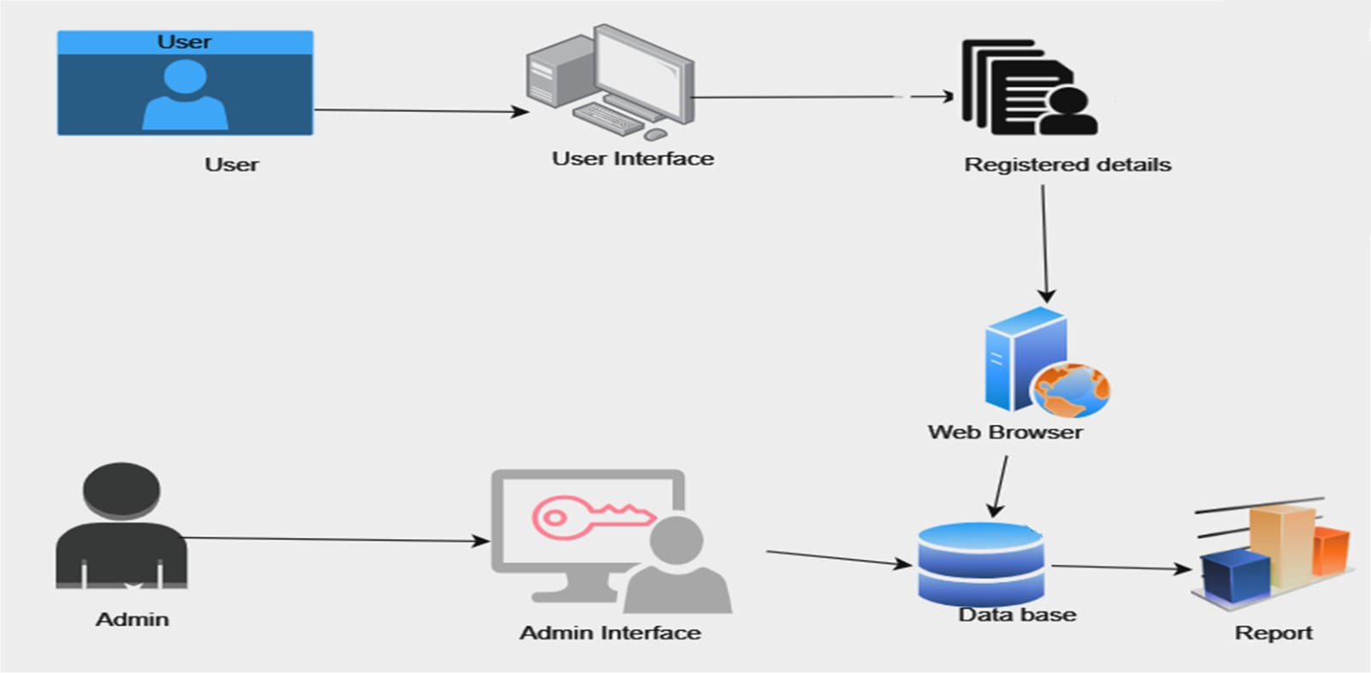

Fig 5.1**:** SystemArchitecture diagram

1. The registered user details are securely stored in a central database, allowing for easy access to information related to each household's waste disposal habits.
2. Administrators have the privilege of accessing this comprehensive database, which equips them with the tools to monitor, analyze, and make informed decisions regarding waste management strategies.
3. The Unique Id generation process enables each user to receive their unique code, which they can then use to update their garbage status, ensuring that every household is actively involved in responsible waste disposal practices.

Over time, the system collects data from users based on Unique Id and updates, enabling administrators to generate comprehensive reports that provide insights into The user registers for the system and provides their name, address, and phone number relevant information it generates a Unique Id for the user and stores it in the user registration details.

1. Waste disposal trends, allowing for continuous optimization of collection routes and schedules. This data-driven approach not only promotes responsible waste disposal but also aligns with broader environmental and sustainability goals, making urban living cleaner and more environmentally responsible

This allowing for easy access to information related to each household's waste disposal habits. Administrators have the privilege of accessing this comprehensive database, which equips them with the tools to monitor, analyze, and make informed decisions regarding waste management strategies. The Unique ID generation process enables each user to receive their unique code, which they can then use to update their garbage status, ensuring that every household is actively involved in responsible waste disposal practices. Over time, the system collects data from users based on Unique IDs and updates, enabling administrators to generate comprehensive reports that provide insights into waste disposal trends, allowing for continuous optimization of collection routes and schedules. This data-driven approach not only promotes responsible waste disposal but also aligns with broader environmental and sustainability goals, making urban living cleaner and more environmentally responsible.

* 1. **Data Flow Diagram (Level 0):**

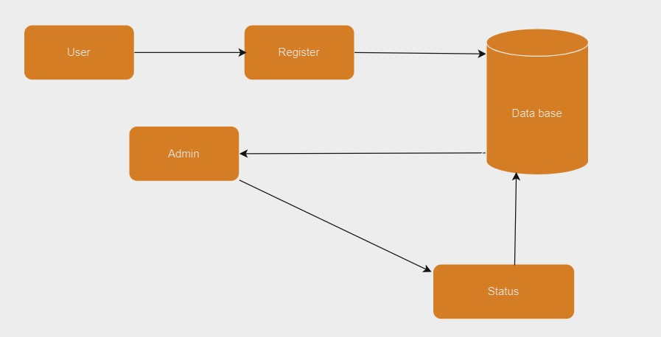

**Fig 5.2: Creating a Unique Id for each individual user**

1. When users sign up for the system, they furnish essential information like their name, address, and phone number, address creating a personalized profile within the system.
2. As a key part of the registration process, a distinct Unique Id is automatically generated for each user, ensuring a unique identifier for their waste disposal activity.
3. This individual Unique Id is securely stored alongside their registration details, creating a seamless link between the user's identity and their waste management activities.
4. The use of Unique Id not only simplifies the process for users but also allows for precise tracking and accountability in garbage disposal practices.
5. This integration of user registration and Unique Id fosters responsible waste management while streamlining data collection and analysis for more efficient urban sanitation**.**
   1. **Data Flow Diagram (Level 1) :**

. Based on Unique Id status reports streamline the tracking of garbage disposal activities, enhancing data accuracy and facilitating prompt intervention when needed.

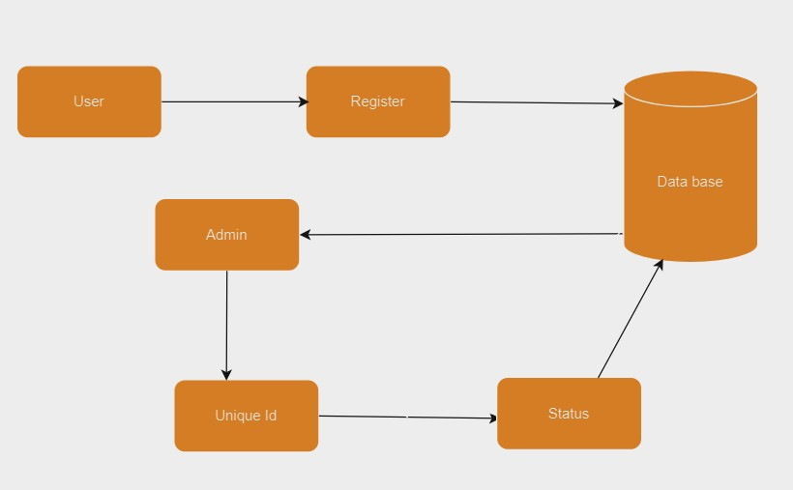

**Fig 5.3: Monitoring the status and storing in database**

These reports play a pivotal role in enhancing the overall accuracy of waste management data, as they serve as a direct and reliable link between users and the system.

By allowing users to update their garbage status through a Clicking Yes or No based on Unique Id, this system ensures that data entry is not only user-friendly but also error-resistant. The real-time nature of the Unique Id-based updates ensures that the waste management system remains up-to-date with the latest information from households.

Moreover, this instant access to the status of garbage disposal facilitates swift intervention when needed. Administrators can easily identify any anomalies or irregularities in waste disposal patterns, enabling them to take immediate action, such as adjusting collection routes or addressing issues related to irresponsible waste disposal. In summary, Unique Id-based status reports represent an advanced and efficient approach to waste management, combining user convenience with data accuracy, thereby promoting responsible waste disposal practices and enhancing the overall effectiveness of urban sanitation efforts

* 1. **UML Diagrams :**
* The class diagram consists of entities such as User, Registration, Admin, and Status, representing the key components involved in the system's functionality and management.

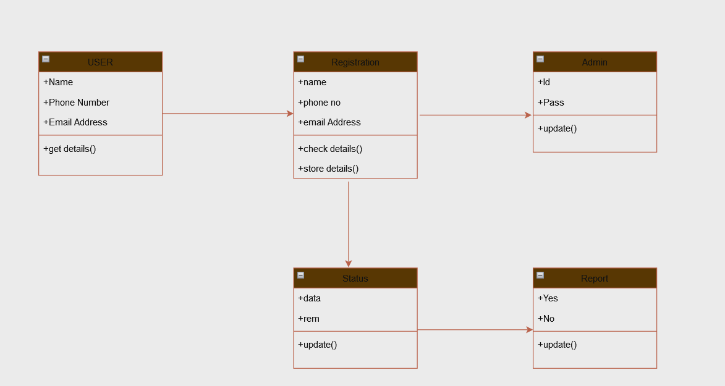

Fig 5.4: Class diagram

The class diagram for the waste management system provides a structured representation of critical entities, serving as the building blocks of the system's functionality. Four central classes, namely User, Registration, Admin, and Status, are fundamental to understanding the core elements within the system.

The Admin class represents the system's administrators, who hold the authority to oversee and control various aspects of waste management, including user data and system operations. Lastly, the Status class serves for monitoring garbage disposal activities, facilitating real-time tracking and data collection.

By visualizing these classes and their relationships within the class diagram, the system's structure and interactions become transparent, supporting effective management and functionality within the waste management initiative.

* The use case diagram for the waste management system includes features such as registration form, Unique Id generation.
* The administrator has access to all core modules, while members have access to specific

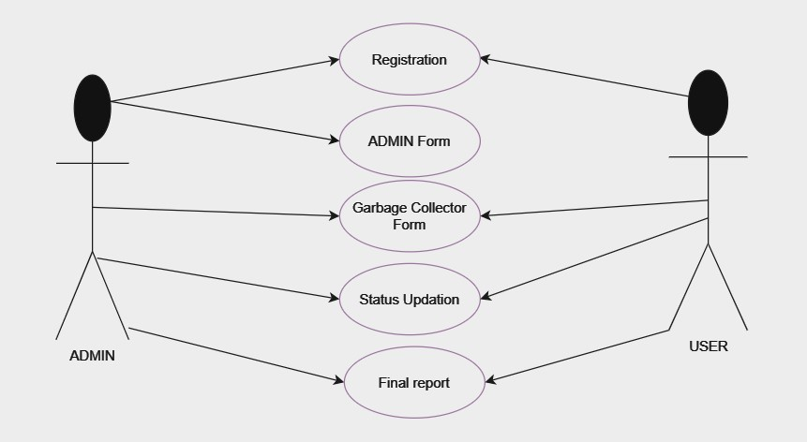

Fig 5.5: Use case Diagram

The use case diagram for the waste management system is a comprehensive representation that encompasses essential features such as user registration forms and Unique Id generation. These features are integral to the system's functionality, as they facilitate user on boarding and efficient tracking of waste disposal activities.

In this system, administrators hold privileged access to all core modules, enabling them to oversee and manage the entire waste management process. On the other hand, members are granted access to specific functionalities, aligning with their roles and responsibilities. This access differentiation ensures that the system is tailored to accommodate both administrative oversight and user interaction, fostering an organized and efficient waste management framework.

Use case represents the system's administrators, who hold the authority to oversee and control various aspects of waste management, including user data and system operations. Lastly, the Status class serves for monitoring garbage disposal activities, facilitating real-time tracking and data collection.

This access differentiation ensures that the system is tailored to accommodate both administrative oversight and user interaction, fostering an organized and efficient waste management framework

The Admin class represents the system's administrators, who hold the authority to oversee and control various aspects of waste management, including user data and system operations. Lastly, the Status class serves for monitoring garbage disposal activities, facilitating real-time tracking and data collection.

**6. IMPLEMENTATION**

In the below figure is main Web page of the project in which we can see with beautiful font with Indian flag and different images and information about the project also owned the copy rights of the page.

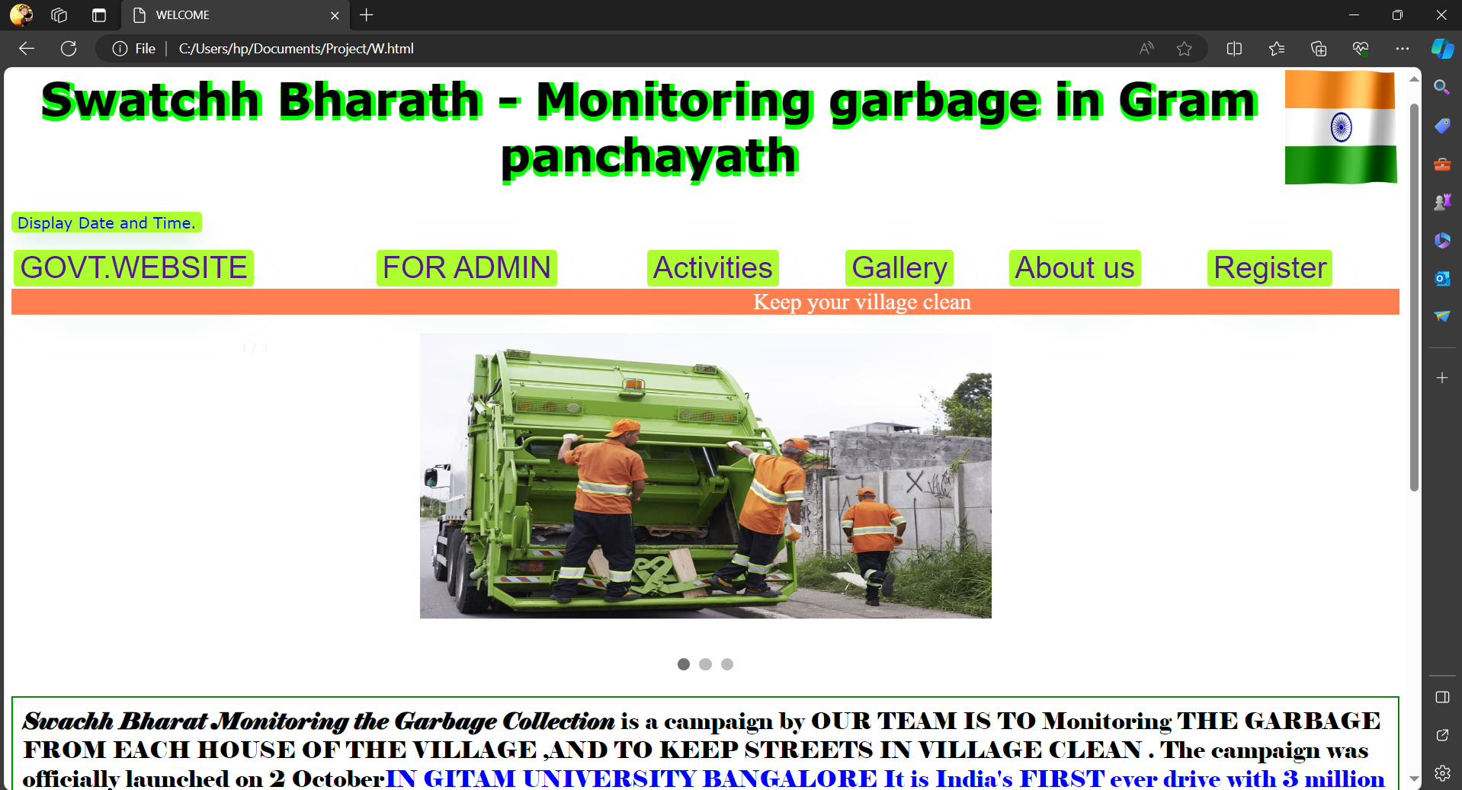

The page has lot of information in top side when we click on Display date and time then it will show the present Indian date time and we click on Govt.Website it will redirect to government page.

Also there are many pages which we can visit through that page.

When we click on Govt.Website it will redirect to government page. Also there are many pages which we can visit through that page.

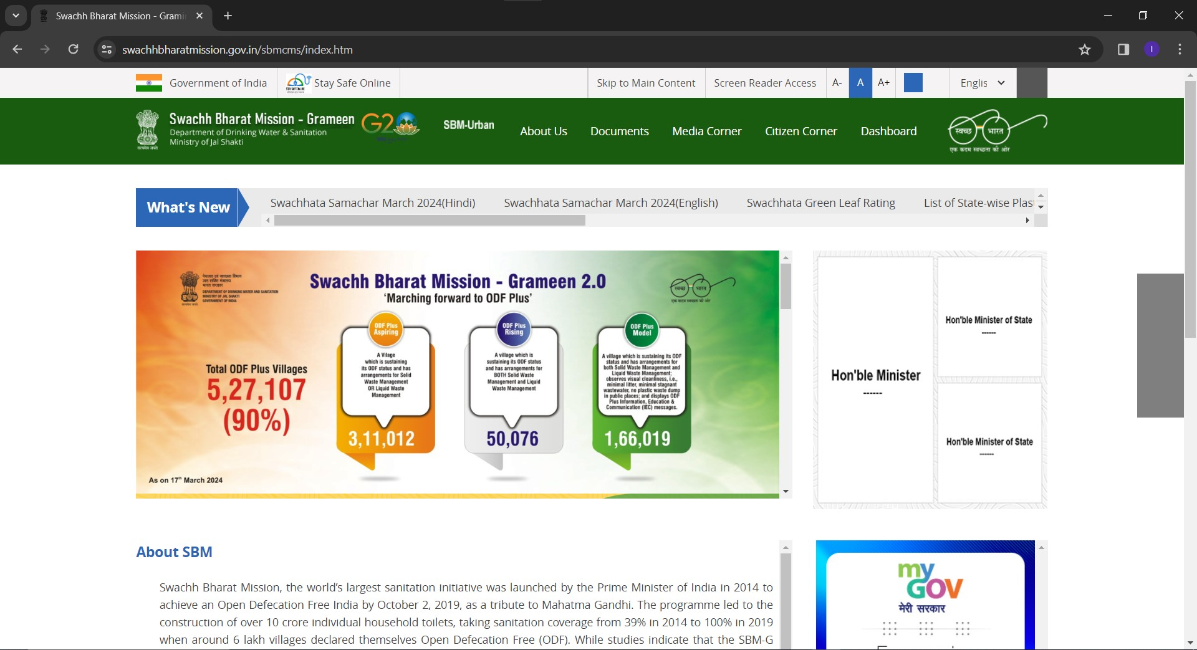

The "Govt. Website" link on our platform serves as a direct gateway to official government pages, providing users with access to authoritative information and resources. Additionally, our platform offers a variety of pages catering to diverse interests and objectives. Users can explore interactive features such as quizzes, where they can test their knowledge and earn certificates upon successful completion. Furthermore, our platform hosts campaigns that allow users to actively engage in environmental initiatives and contribute to meaningful causes. With a range of opportunities for learning, certification, and participation, our platform strives to empower users to make a positive impact on their communities and the environment.

Next Welcome to our "About Us" page, your go-to destination for all inquiries and related questions. Here, users can find valuable information and answers to various queries at any time. Whether you seek details about our services, company mission, or team members, this page serves as a comprehensive resource. Additionally, users are encouraged to contact the Admin directly for any further assistance or doubts they may have. We strive to ensure your experience with us is informative, transparent, and seamless. Thank you for visiting, and please don't hesitate to reach out with any questions you may have.

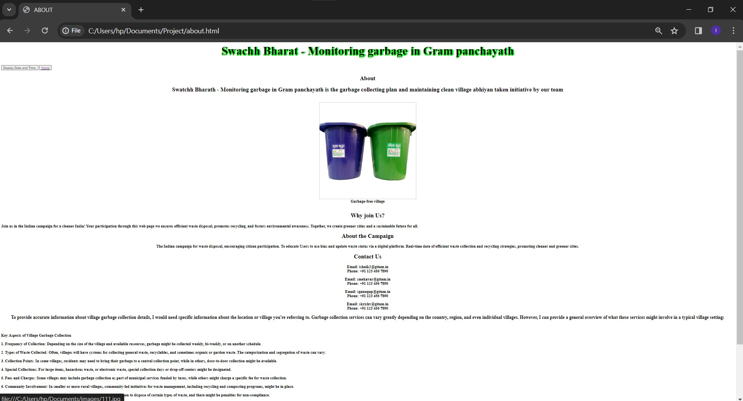

In page, your trusted source for discovering more about our organization and the values we uphold. Here, you'll find a wealth of information covering various aspects of our company, including our background, mission, and core beliefs. Delve deeper to learn about our commitment to excellence, sustainability, and customer satisfaction. Additionally, explore insights into our team members and their dedication to driving our vision forward. Should you have any further inquiries or require assistance, please don't hesitate to reach out to our dedicated team. Thank you for taking the time to get to know us better, and we look forward to serving you with integrity and passion.

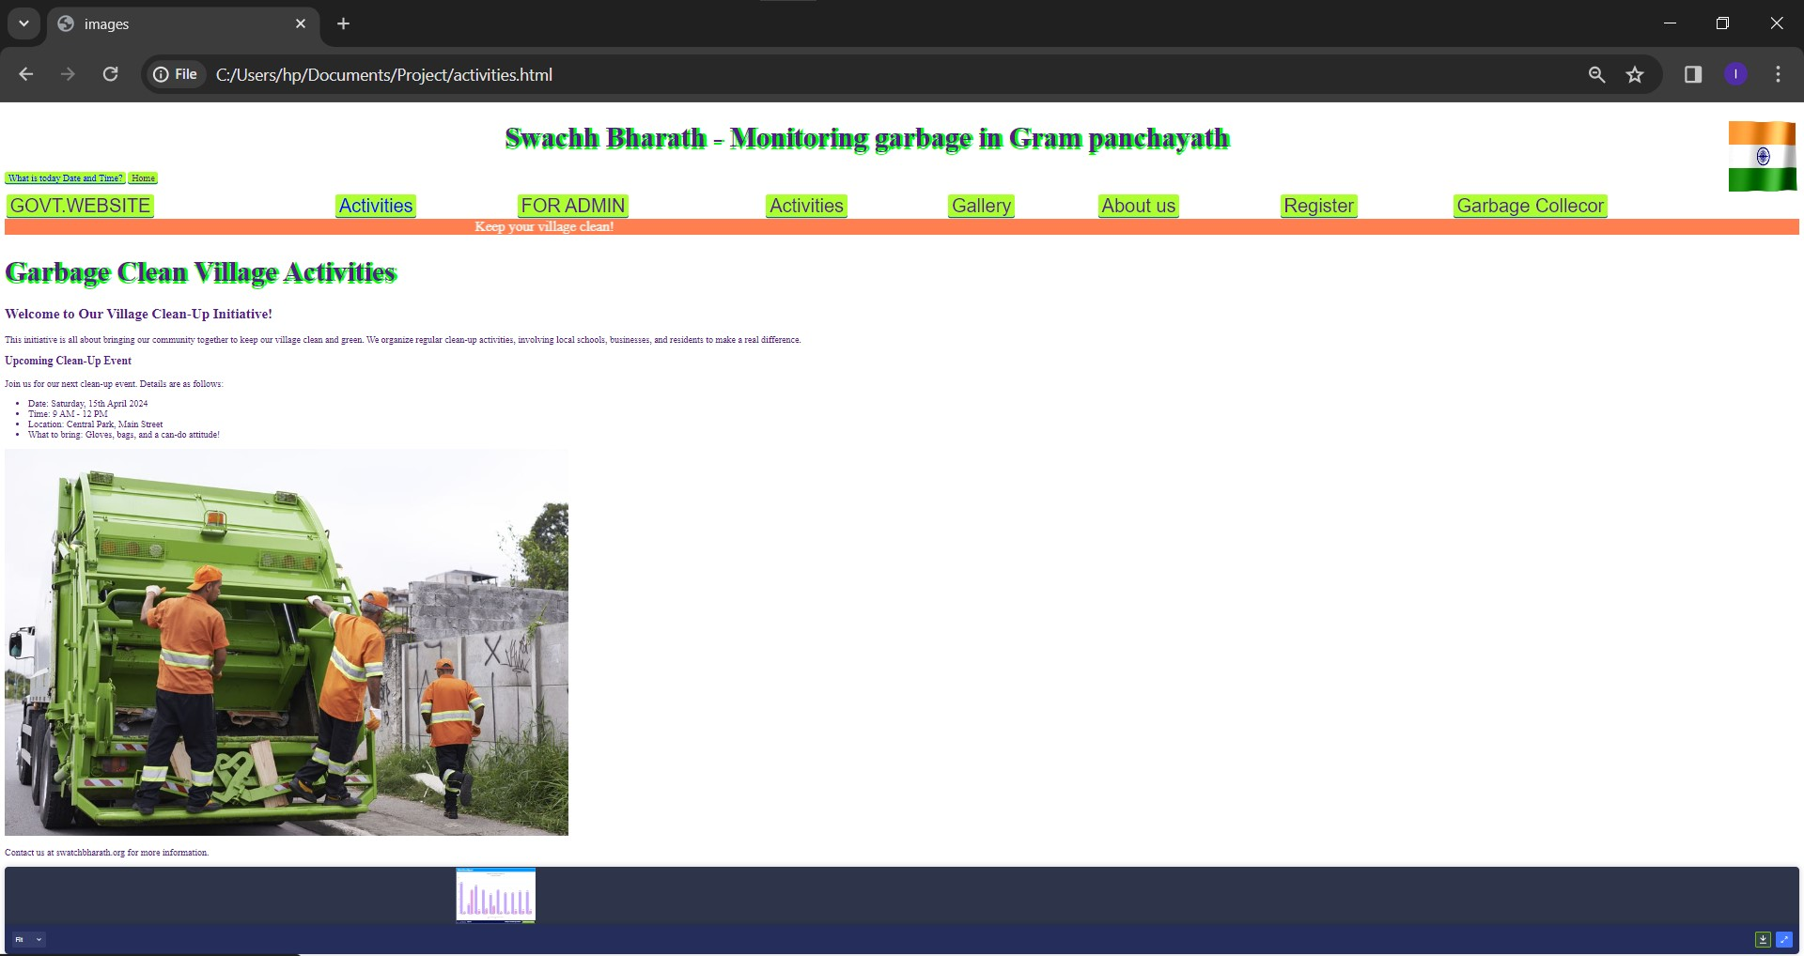

Our activities page presents the availability schedule, showcasing accessible time slots for various activities. Users can easily grasp this information through a user-friendly bar graph format, clearly indicating the duration of availability for each activity. This visual representation simplifies monitoring and planning, empowering users to efficiently organize their schedules by swiftly identifying when activities are open.

The activities page on the website displays the availability schedule, showing the time slots when activities are accessible. Users can view this information in a straightforward bar graph format, indicating the duration of availability for each activity. This visual representation simplifies monitoring and planning, allowing users to quickly identify when activities are open and plan their schedules accordingly.

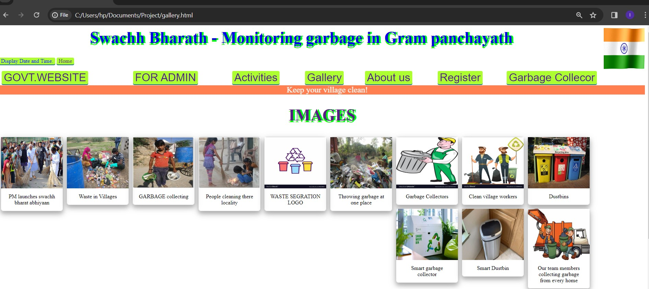

Our gallery page proudly showcases our achievements and milestones, serving as a testament to our dedication and hard work. Here, visitors can explore our past accomplishments and celebrate our journey thus far. Additionally, we provide a glimpse into our future goals, offering insight into our aspirations and vision for the days ahead. Through captivating visuals and informative descriptions, we invite you to join us on this exciting journey of growth and progress. Together, we look forward to achieving even greater success in the future**.**

Here, you'll find a visual journey through our past achievements, highlighting milestones and moments of success. Additionally, we provide insights into our future goals, illustrating our vision and commitment to continuous improvement and growth. We invite you to explore this space and witness our dedication to excellence and innovation. Together, we aim to shape a brighter tomorrow through our ongoing endeavors and aspirations.

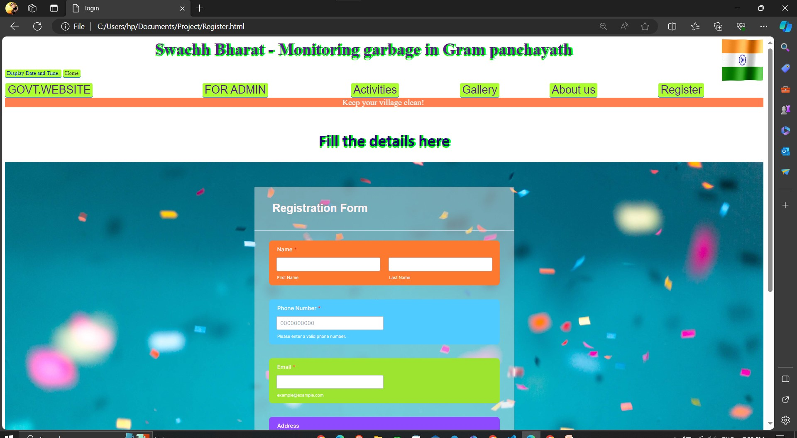

Registraion Form along with basic details Name, Mobile number, Email, Address.

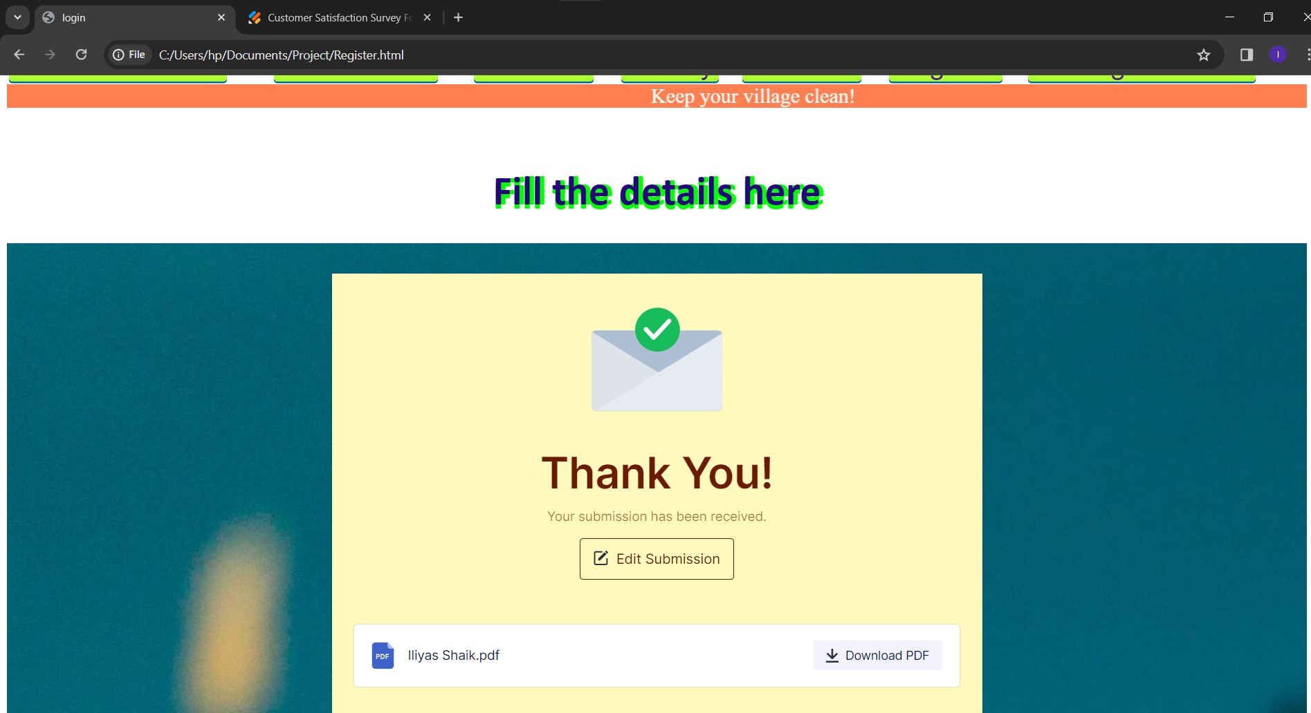

After collecting the Thank You page where you can download the document or Edit the submission

The user registration process for this project is facilitated through a web-based form created with HTML, styled for user-friendliness using CSS. This form collects critical user information, including their name, address, and phone number. Data accuracy is ensured through form validation, both on the front end with HTML attributes and potentially through additional validation in JavaScript, such as phone number format checks.

Upon submission of the form, JavaScript is responsible for capturing the data provided by the user. In a comprehensive project, this collected information would then be securely transmitted to a server for further processing. On the server side, a database schema is typically designed to store user details, often including fields like name, address, and phone number.

It's crucial to emphasize the importance of security measures in data transmission to protect user information. Using HTTPS for encryption and implementing robust security practices will help safeguard sensitive data. This registration process is a fundamental step in the broader initiative to improve waste management through user data collection and database utilization.

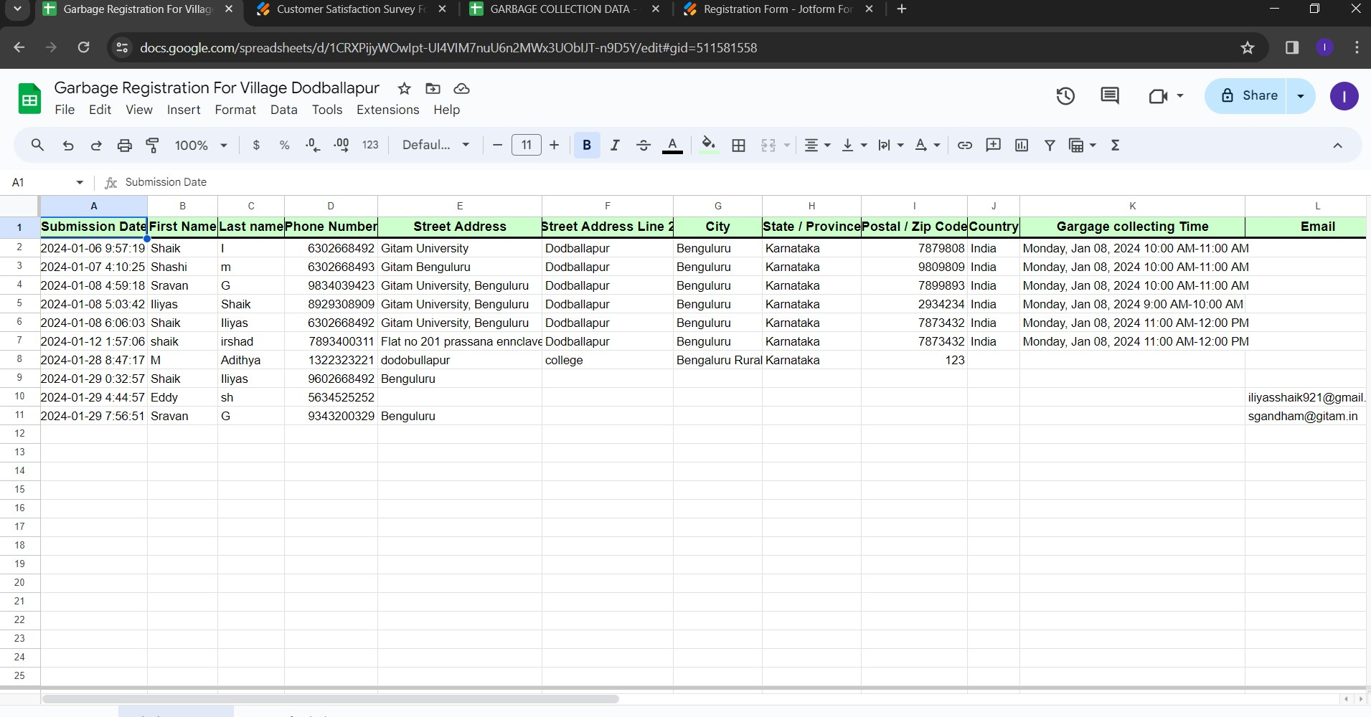

After the Registration of User the Unique Id code Generation

This approach combines HTML for creating the form, CSS for styling, and JavaScript for data collection. The collected data is then typically sent to a server and stored in a database for further processing and retrieval when needed.

Unique Id based status reports represent an advanced and efficient approach to waste management, combining user convenience with data accuracy, thereby promoting responsible waste disposal practices and enhancing the overall effectiveness of urban sanitation efforts. Using HTTPS for encryption and implementing robust security practices will help safeguard sensitive data. This registration process is a fundamental step in the broader initiative to improve waste management through user data collection and database utilization

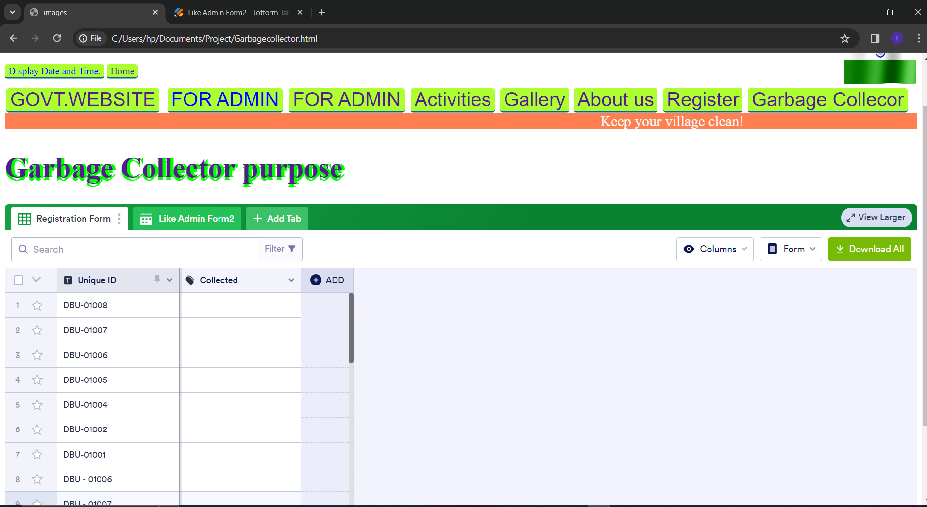

Garbage Collector form can be easily updated based on Unique Id

Utilizing a Google Form for data updates after scanning a Unique Id streamlines the process of modifying user information, such as name, address, and phone number. Upon scanning the Unique Id, users are seamlessly directed, displaying their existing data. This approach simplifies the update process, as users can easily edit their information as needed.

The integration of Unique Id in Admin Form not only enhances user convenience but also improves data accuracy, reducing the risk of input errors. It provides a user-friendly and familiar interface, making it accessible to a wide range of users.

Moreover, the ability to open a pre-populated ensures that the data remains consistent and standardized, facilitating efficient data management. This approach offers administrators a straightforward way to keep user information up-to-date and accurate, which is essential for effective waste management and urban sanitation efforts.

Overall, this Unique Id Admin Form combination enhances the efficiency and reliability of updating user details, a vital component of your waste management project. It streamlines the process for users and administrators, contributing to the overall success of your initiative.

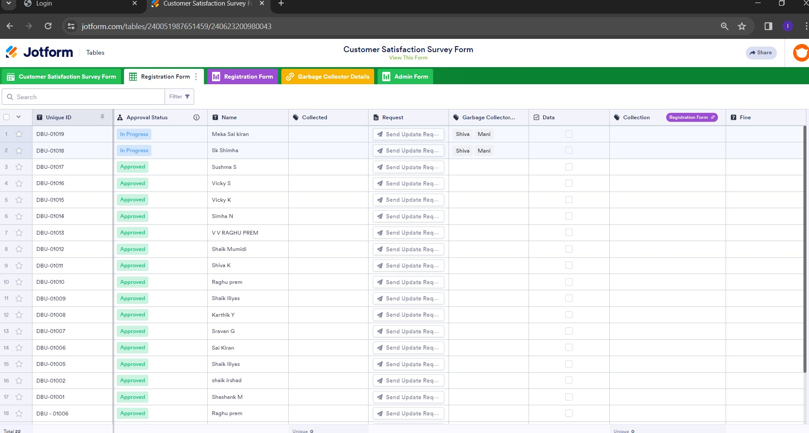

In the Admin form, users can conveniently track the status of tasks, distinguishing between those approved, in progress, or completed. Additionally, it provides insights into the collection status, indicating whether garbage was successfully collected or remains uncollected. Users can also view details about the assigned garbage collector responsible for each task, facilitating accountability and communication. Moreover, the form includes information on any fines incurred, allowing for efficient management of penalties and enforcement. This comprehensive overview empowers administrators to monitor operations effectively and ensure timely completion of tasks while promoting accountability and compliance

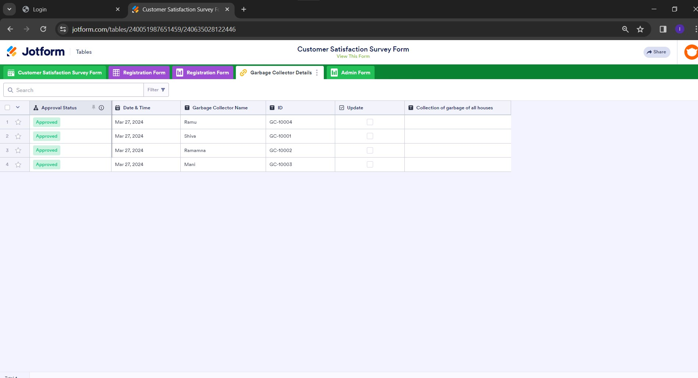

These are Information about the garbage collectors with their Id’s and all the dates they ate available.

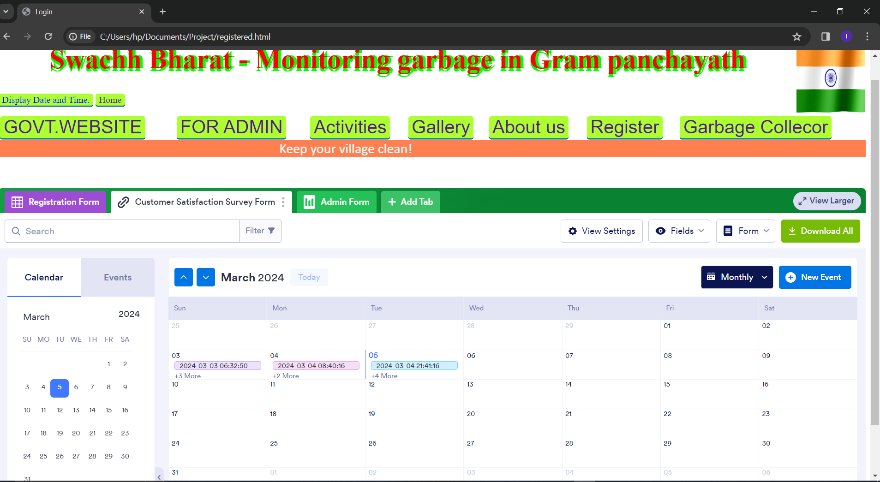

In this calendar we can monitor daily, weekly and monthly wise submissions effectively.

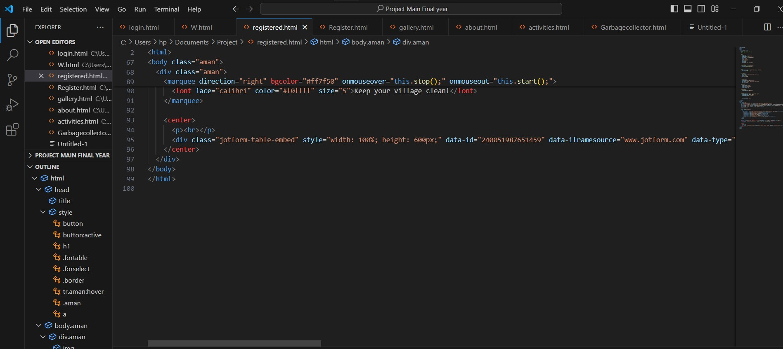

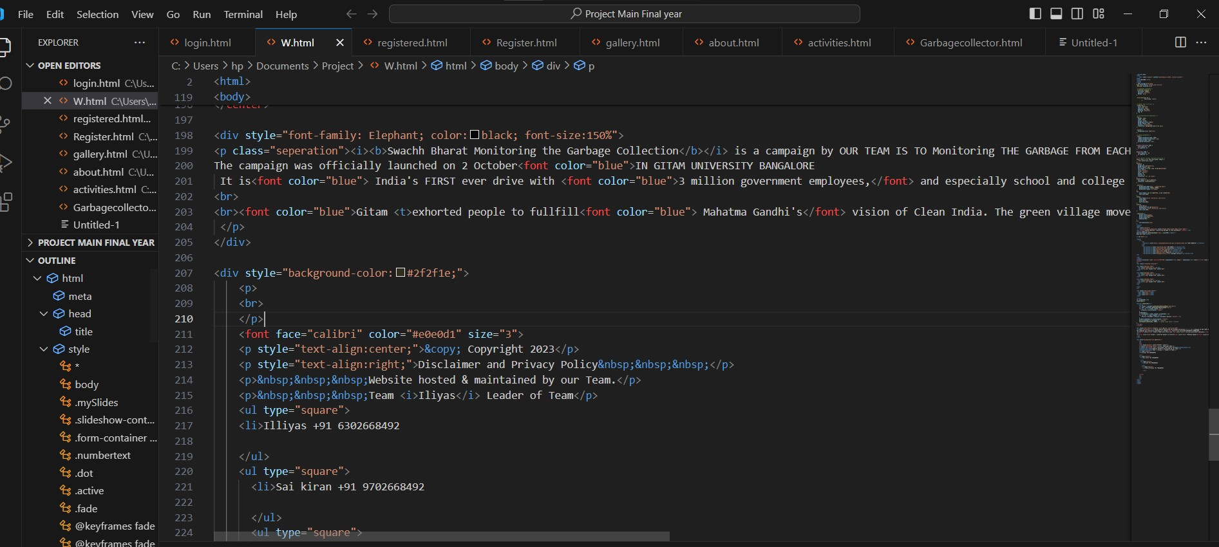

Some information of code which is implemented through HTML, CSS, JavaScript.

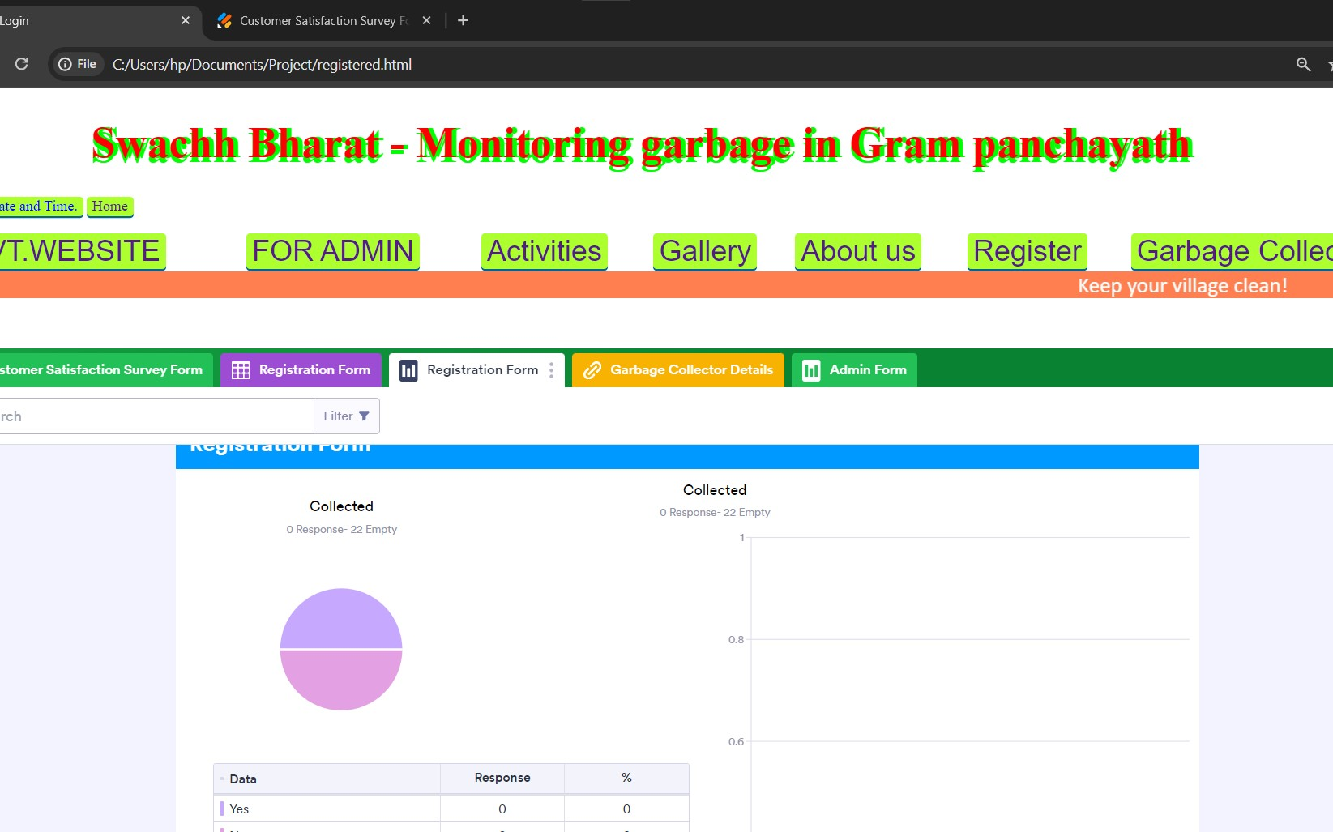

The final report on the garbage collection page presents a detailed bar chart illustrating the status of garbage collection. Each bar represents a specific timeframe, displaying whether garbage was collected or not during that period. This visual representation provides a clear overview of the collection status over time. Users can easily track trends and patterns, facilitating informed decision-making and planning. With this comprehensive visualization, stakeholders can assess the efficiency of garbage collection efforts and identify areas for improvement. The interactive nature of the bar chart enhances user engagement and understanding. It serves as a valuable tool for monitoring and optimizing waste management processes, ultimately contributing to a cleaner and more sustainable environment. facilitating informed decision-making and planning. With this comprehensive visualization, stakeholders can assess the efficiency of garbage collection efforts and identify areas for improvement. The interactive nature of the chart enhances user engagement and understanding, making it a valuable tool for optimizing waste management processes and promoting environmental sustainability.

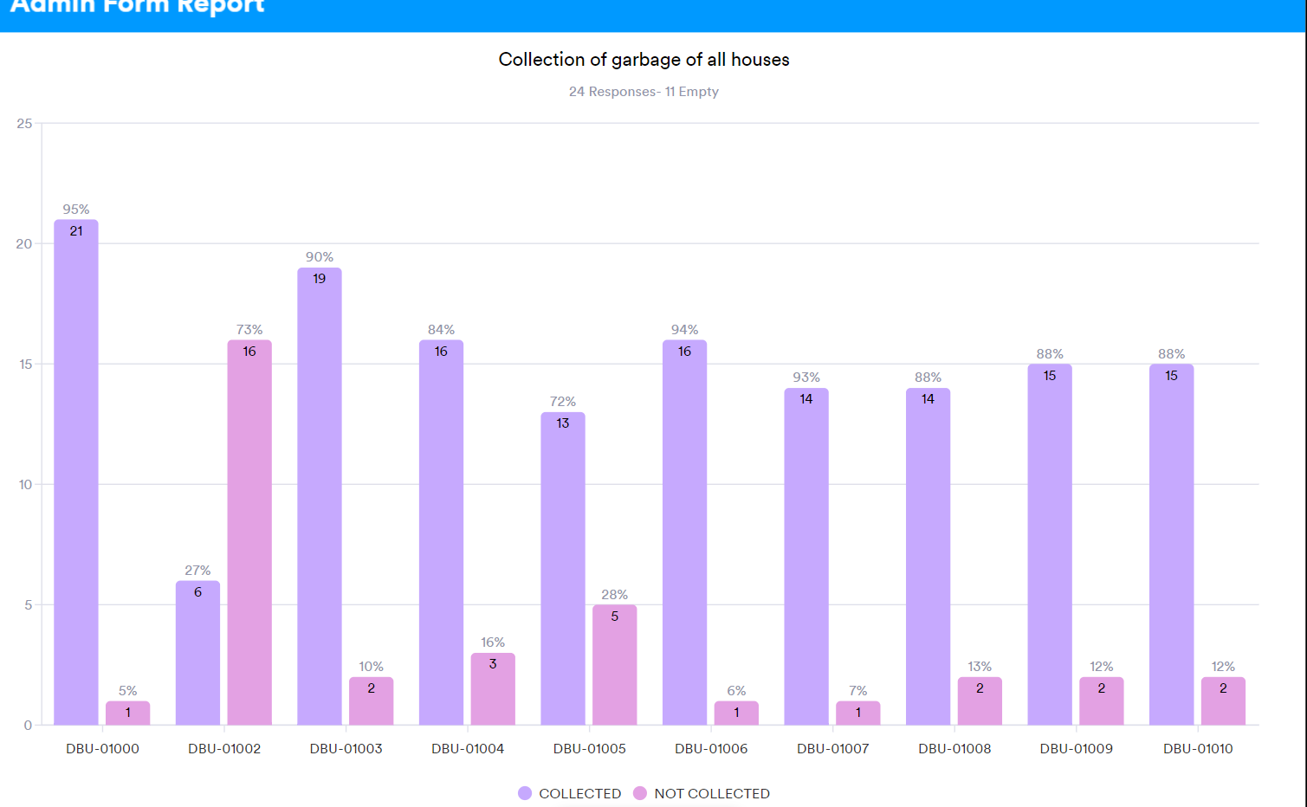

The final report on the garbage collection page presents a detailed bar chart illustrating the status of garbage collection. Each bar represents a specific timeframe, displaying whether garbage was collected or not during that period. This visual representation provides a clear overview of the collection status over time. Users can easily track trends and patterns, facilitating informed decision-making and planning. With this comprehensive visualization, stakeholders can assess the efficiency of garbage collection efforts and identify areas for improvement. The interactive nature of the bar chart enhances user engagement and understanding. It serves as a valuable tool for monitoring and optimizing waste management processes, ultimately contributing to a cleaner and more sustainable environment. The garbage collection page offers a comprehensive report through a detailed bar chart, showcasing the status of garbage collection over time.

**Conclusion**

Utilizing web technology enables us to monitor the garbage status of every user meticulously, generating comprehensive reports that contribute significantly to fostering greenery and promoting a healthy environment. Through this approach, we can efficiently track waste disposal habits, identify areas for improvement, and implement targeted strategies to enhance environmental sustainability. By providing users with real-time insights and actionable data, we empower them to make informed decisions and actively participate in preserving our planet. Ultimately, our efforts towards leveraging web technology for waste management not only promote greenery but also contribute to creating a cleaner, healthier environment for current and future generations to thrive.

By leveraging web technology, we can effectively monitor the garbage status of every user, generating comprehensive reports that contribute significantly to promoting greenery and a healthy environment. This technological approach allows for real-time tracking of waste disposal habits, enabling us to identify trends, patterns, and areas for improvement. By fostering transparency and accountability, we empower individuals to actively participate in responsible waste management practices, ultimately leading to a cleaner and greener environment. Through the utilization of web-based monitoring systems, we take proactive steps towards sustainable living, ensuring the preservation of our natural surroundings for future generations.

Our platform revolutionizes the monitoring of waste disposal practices for each user, marking a significant stride towards environmental sustainability. By harnessing the power of the internet, we can track and analyze garbage status in real-time, offering insights that drive positive change. Through personalized reports and data visualization, users gain a deeper understanding of their environmental impact, fostering a sense of responsibility and encouraging eco-conscious behavior. This digital approach not only promotes greenery but also cultivates a healthier environment for all. With our innovative solution, we empower individuals to make informed choices that contribute to a greener, more sustainable future.

**Future Work**

In our ongoing commitment to enhancing our platform, we have outlined several key areas for future development and improvement. Firstly, we recognize the importance of addressing any existing bugs or glitches on our webpage. Through rigorous testing and debugging processes, we aim to ensure a seamless and user-friendly experience for all our users.

Additionally, security is a top priority for us, and we are dedicated to implementing robust measures to safeguard user data and protect against potential threats. This includes encryption protocols, firewall enhancements, and regular security audits to identify and address vulnerabilities proactively.

Furthermore, our admin form plays a crucial role in managing our platform effectively. We plan to refine and optimize this form to streamline administrative tasks, improve data management capabilities, and enhance overall usability.

In line with our commitment to continuous improvement, we also have plans to develop new modules and features to expand the functionality and versatility of our platform. These may include advanced reporting tools, integration with external systems, and additional user customization options.

Moreover, we understand the importance of user feedback in driving our development efforts. As such, we will continue to solicit input from our users to identify areas for improvement and prioritize enhancements based on their needs and preferences.

In summary, our future work will focus on addressing webpage bugs, enhancing security measures, optimizing the admin form, and developing new modules to enrich the user experience. Through these efforts, we aim to maintain our position as a leading provider of innovative and reliable solutions for waste management and environmental sustainability.

**REFERENCES**

**[1] Ketan H. Pakhmode, Ronit R. Dudhe, Gangadhar S. Waghmare, Daniyal A. Kamble, Kirti Dhenge “Solar powerd water surface garbage collecting boat”, International Research Journal of Engineering and Technology (IRJET) , 6, 3, 3223-3225, (2019).**

**[2] Nallapaneni Manoj Kumar, Sonali Goel and Pradeep Kumar Mallick,"Smart Cities in India:Features, Policies, Current Status, and Challenges", IEEE International Conference on Technologies for Smart-City Energy Security and Power (ICSESP-2018), March 28-30,2018.**

**[3] Yuan-Cheng Lai, Frannie Han, Yi-Hsuan Yeh, Ching-Neng Lai and Yu-Chin Szu, “A GPS navigation system with Unique Id decoding and friend positioning in smart phones,” 2 nd International Conference on Education Technology and Computer (ICETC), pp.V5-66-V5-70, 22- 24 June 2010**

**[4] Anukriti Jha, Anshuman Singh, Roshan Kerketta, Deepak Prasad, Kumari Neelam and Vijay Nath “ Development of Autonomous Garbagr Collector Robot”, Third International Conference on Microelectronics, Computing and Communication Systems, 567-576, (2019)**

**[5] Sumit Tiwari, Sandeep Sahu, “A Novel Approach for the Detection of Sheet Tampering Using Encrypted Unique Id”, IEEE - International Conference on Computational Intelligence And Computing Research (2014), Coimbatore – India, 2014, pp. 604-608.**

**[6] Vermeulen Y, Niemann W, Kotzé T. Supply chain integration: A qualitative exploration of perspectives from plastic manufacturers in Gauteng. J Transp Supply Chain Manag 2016;10(1):1-13.**

**[7] L. Laskowski, “Google Forms and Sheets for library gate counts,” J. Access Serv., vol. 13, no. 3, pp. 151–158, Jul. 2016.**

**[8] M. P. A. Murphy, “"Blending" Docent Learning: Using Google Forms Quizzes to Increase Efficiency in Interpreter Education at Fort Henry,” J. Museum Educ., vol. 43, no. 1, pp. 47–54, Jan. 2018**

**[9] Jacob Pharo, “Web Development changing in response to mobile technologies”, University of Wisconsin – Spring 2014, api-242440721**

**[10] Fatemeh Bordbar, “The effectiveness of website design in highereducation recruitment”, April 2016, Project work by Southern Utah University**